Areas of Strategic Planning and Assessment Council Attention for 2017-2018
Specific Action Items related to Strategic Plan from Provost/Cabinet:
Integrate EI VII (Build Quality Online Education) into EI I (Nurture Innovation and the Learning Environment). Review and make recommendations regarding Institutional Learning Outcomes in college mission statement.
- The Council made recommendations on revising the Institutional Learning Outcomes, updating them and making them more reflective of the outcomes we expect from a New Paltz education. The Council also integrated Essential Initiative VII, Building Quality Online Education, into Essential Initiative I, Nurture Innovation and the Learning Environment. Because the goal of developing online learning at New Paltz is closely tied to graduate program offerings and other initiatives across the institution, it makes sense to connect them in the Strategic Plan.
Oversee implementation of Strategic Plan with 8 Essential Initiatives
- Using recently established goals provided by Provost, the Council reviewed this year’s goals of each division related to initiatives of strategic plan. The Council also reviewed the Strategic Planning Priorities given at the end of the term of the last Strategic Planning Council. One of the main areas of focus was Academic Advising, emphasized in Strategic Plan development as an area needing significant attention. Dante Cantu, Executive Director of Academic Advising and Student Success, provided an overview of the plan for Academic Advising and Student Success, including baseline data, their planning and assessment process and progress to date. On a related topic, Lucy Walker, the Director of the Office of Institutional Research, offered a presentation of current retention data for us to consider, as one of the priorities given to us at the beginning of the semester was to continue activities to enact strategies to improve student success (including retention rates and graduation rates), including freshman pre-registration, Early Warning System, and peer-to-peer support. Much of what Academic Advising and Student Success is doing addresses these areas, so the Council will continue to monitor progress there. Another area of attention was to develop further new faculty support and ongoing faculty development. This is also a topic of the RTP Ad Hoc Committee, and Isidoro Janeiro Council Co-Chair and Chair of the Ad Hoc Committee is keeping the Council informed of their discussions/progress and involving us as needed.
Developing Ongoing Planning
- Laurel Garrick Duhaney, Associate Provost for Strategic Planning and Assessment came to the Council meeting on March 7 to give an overview of the Institutional Effectiveness Plan she has been working on to describe planning and assessment on campus. Based on feedback that the Council gave, she has now created three documents from that one, and the Council has given some feedback on those from the big-picture perspective of what it has learned so far about planning on campus. The Council is gaining an understanding of how ongoing planning happens on campus and where it connects in to area/divisional goals and to the Strategic Plan.
Based on this knowledge, the Council is beginning to strategize about how to focus on planning and have assessment efforts follow planning objectives and cycles, which will achieve a reduced (but increasingly effective/meaningful assessment process). Future work includes improving connections in the planning process so that it ultimately ties to budget process.
The Council also will focus more on looking at assessment in terms of planning goals, to reduce the amount of assessment we do and focus it more on looking at the outcomes of the planning goals/metrics we establish.
As the members of the Strategic Planning and Assessment Council learned about planning on campus and worked with its charge, themes emerged to which the Council kept returning: communication, connection/belongingness and community. While we have achieved much in the implementation of our Strategic Plan, throughout its discussions, the Council recognized the need to make the plan more meaningful by articulating ways it reflects our values as well as our mission and goals.
Some of the SPAC’s time this year was devoted to discussing sustainability. Given the College’s interest in sustainability efforts and its attainment of important sustainability goals, the Council discussed recommending inclusion of sustainability into the Strategic Plan. The Council sought to broaden the discussion from our campus sustainability plan with a focus on energy and facilities to incorporate broader sustainability goals. To do this, the Council was introduced to the UN’s Sustainable Development Goals (SDGs). These 17 goals (see below) express the intent of leaders from around the world to make significant progress in creating a sustainable world by 2030. As the Council talked about these goals, the members became excited. Each could see where their work intersected in some way with at least one of the goals and began to discuss how these goals allowed them to fit what they do into a structure of purpose and value that seemed lacking prior to looking at this framework.

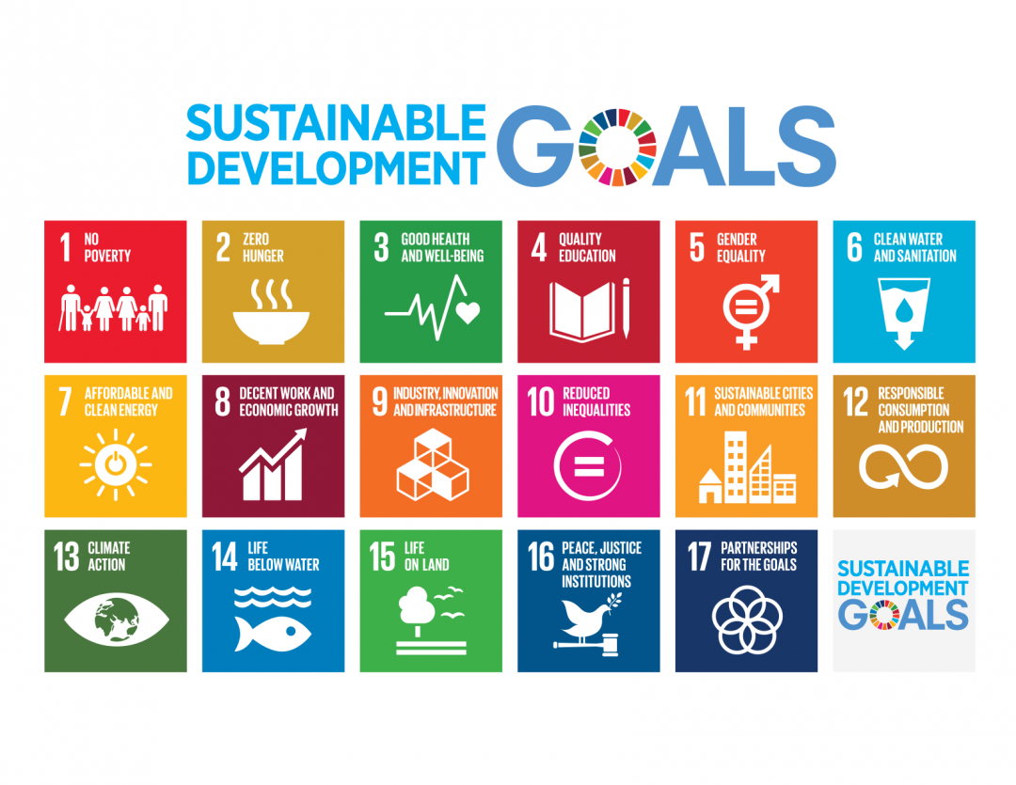
The Council’s initial excitement and desire to contribute to all of the goals was tempered by the all-encompassing nature of the goals. The Council agreed that our main focus as an educational institution is reflected in Goal 4: Quality Education: Ensure inclusive and equitable quality education and promote lifelong learning opportunities for all. Within this main goal, many of the other goals could work together to create a framework into which almost all aspects of our work across the institution fit.
The Council then began to discuss how our current Strategic Plan could map onto these development goals. Relying heavily on a document published by the Sustainable Development Solutions Network (Australia/Pacific) entitled “Getting Started with the SDGs in Universities: A Guide for Universities, Higher Education Institutions, and the Academic Sector”, The Council shares and propose the following.
The ways in which educational institutions can support the SDGs through their regular activities and incorporate them into their existing structures are these:
• Learning and Teaching
• Research
• Organizational governance, culture and operations of the university
• External Leadership
These also reflect, broadly, the areas of our Strategic Plan, and the Council recommends that it continue to work on articulating the ways in which the most relevant of the Sustainability Goals fit into our Strategic Plan by engaging in the following activities in the upcoming year, in addition to the other elements of our charge:
- Mapping what we are already doing (relating the Essential Initiatives to the Goals)
- Building internal capacity and ownership of the SDBs
- Identifying priorities, opportunities and gaps
- Integrating, implementing and embedding the SDGs within university strategies, policies and plans
- Monitoring, evaluating and communicating their actions on the SDGs.
In addition to the sense of the members of the Council that it is important to the implementation of the Strategic Plan that we make it as meaningful as possible to all campus constituents, the value of linking the Plan to the broader Sustainability goals became clearer as the Council learned more about the goals. The ways in which the work we do across campus already links to the goals are many, and the opportunities to use these goals as a framework to connect and communicate on campus, in the region and to funders and prospective students are exciting and present rich opportunities that the Council would like to explore further.

